ERASMUS*

VI Liceum Ogólnokształcące
Bydgoszcz
Code du projet: 2023-1-PL01-KA121-SCH-000127337
Short term group Mobility Catanzaro, Italia from 18 to 25 March 2024
Hosting school : Istituto d’Istruzione Superiore « Giovanna De Nobili », Catanzaro Italia
Sending school:
Quand | Monday  18 March | Tuesday  19 March | Wednesday  20 March | Thursday  21 March | Friday  22 March | Saturday  23 March | Sunday  24 March | Monday  25 March
Activities | Arrival  Catanzaro  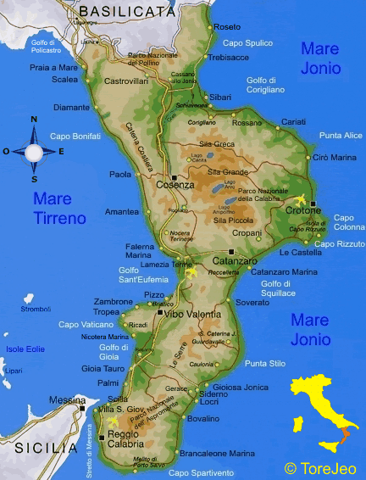 | 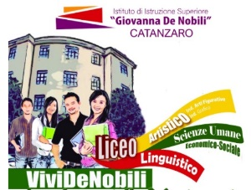  Liceo Linguistico, delle Scienze Umane ed economico-sociale,  Liceo artistico  8 :00-8 :8 :15 School visit  8:15-9:00  Lessons  9:00-9:30 Break  9 :30-12 :00 Headmaster’s welcome M. Angelo Gagliardi  Program:  Meeting with Mrs. Patrizia Costantino  President of the local  Slow Food Community  Slow Food International  The Mediterrenean diet for personal well-being and sustanaibility  Kahoot  Lunch and afternoon with the host family | 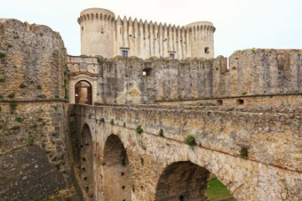  8:00-departure for Santa  Severina  A visit to the Castle of Santa Severina | Calabria Region Official Tourism website (calabriastraordinaria.it)  Visiting the castle  12:00 departure for  The Russo&Longo Cave  Home | Russo & Longo (russoelongo.com)  Lunch (tasting typical products)  15 :00 Departure for Le Castella  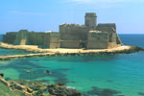  Le Castella in Calabria | Your Travel to Calabria  18:00 Back to Catanzaro | Liceo Linguistico, delle Scienze Umane ed economico-sociale  Liceo artistico  8 :00-10 :00 Lessons  !0 :30-13 :00  Guided tour in Catanzaro  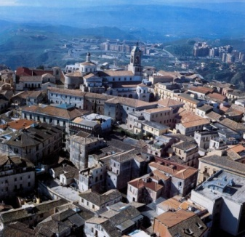  pocket lunch  15:00 Visit to the Parco della Biodiversità  Parco della biodiversità di Catanzaro: orari e cosa vedere - GreenStyle  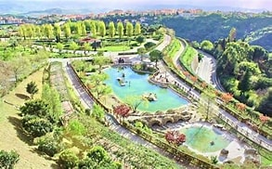 | Liceo Linguistico, delle Scienze Umane ed economico-sociale  Liceo artistico  8:00-departure for Il Granaro  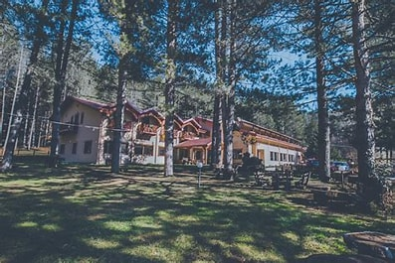  Parco Hotel Granaro – Tanta meraviglia nel cuore della Sila Piccola  Cooking pasta workshop  Fitwalking or Padminton  Lunch at the restaurant  17h00 Back to Catanzaro | Liceo Linguistico, delle Scienze Umane ed economico-sociale,  Liceo artistico  8:00-departure for Pizzo  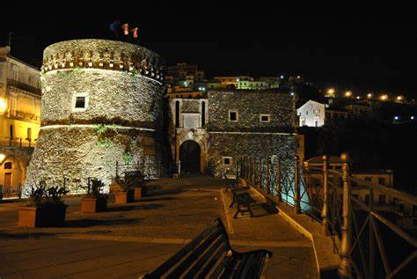  Mindfulness Workshop:  - Introduction to Mindfulness  - Practical Exercises  - Breath Meditation)  Visit to the castle  Murat Castle in Pizzo Calabro: A Walk Through History - Calabrisella Mia (calabrisellamiablog.com)  pocket lunch and tasting of the typical ice cream at the Gelateria Callipo.  Tartufo di Pizzo: the greatest ice cream in the world - Great Italian Chefs  16h00 Tropea sightseeing  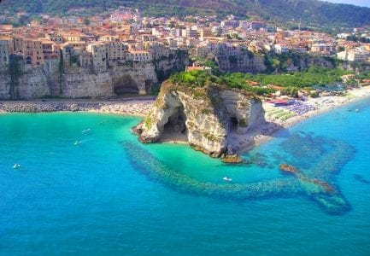 | With the host family | Departure at

